**­**

**Hybrid LED Lighting with Wi-Fi IP Camera**

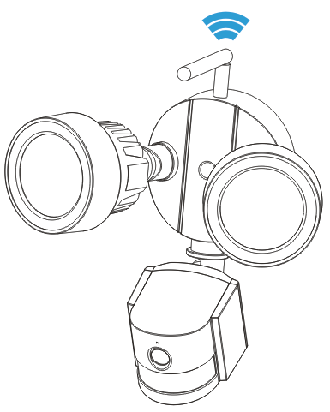



**Contents**

1. Overview……………………………………………………………………………………………………………………………………….……..1

2. Package contents…………………………………………………………………………………………………………………………….……1

3. Appearance………………………………………………………………………………………………………………………………….……….2

4. Installing the mobile App………………………………………………………………………………………………………………….…..3

5. Connecting the camera to your network………………………………………………………………………………………….……3

5A How to add camera in the App…………………………………………………………………………………………….…………..3

Method1: One Key to Add Camera……………………………………………………………………………….…………………..3

Method2: Scan the camera’s QR code or input the DID directly…………………………………………………………5

Method3: Search camera in the LAN…………………………………………………………………………………………………6

5B Wireless Network Connection…………………………………………………………………………………………………...…….7

6. Insert a Micro-SD card for recording………………………………………………………………………………….………..7

7. Install the Wi-Fi antenna…………………………………………………………………………………………………….…….………….8

8. Camera installation guide……………………………………………………………………………………………….………….…………8

8A Camera Location Tips ………………………………………………………………………………………………………..……………8

8B Camera Field of View…………………………………………………………………………………………………………….………..9

8C Lighting & Environment Tips………………………………………………………………………………………………….………..9

8D Tools Required (not included)……………………………………………………………………………………………………..…10

8E Installation Steps …………………………………………………………………………………………………………………………..10

8F LED and Camera Angle/Direction Adjustment…………………………………………………………………….……….….10

9. Main function introduction…………………………………………………………………………………………………………..…....11

9A LED working mode………………………………………………………………………………………………………………..……....11

9B Environmental illumination threshold setting for Day/Night mode switch ………………………….……..13

9C PIR trigger sensitivity setting…………………………………………………………………………………………….……………13

9D Notification push setting for PIR trigger…………………………………………………………………………………………14

9E Notification push setting for Motion Detection trigger……………………………………………………………..…...15

9F Recording to a Memory Card………………………………………………………………………………………..………….…....15

9G My messages………………………………………………………………………………………………………………………….……..16

10. Specifications……………………………………………………………………………………………………………………………….……16

11. Troubleshooting………………………………………………………..……………………………………………………………………...17

|  |  |
| --- | --- |
| **1** | **Overview** |

Thanks for your purchase of this hybrid LED lighting with HD Wi-Fi IP Camera! Get yourself familiar with

all of the ports and connections on the camera and have a look at the user manual for instructions on

how to install the camera and how to use mobile App software.

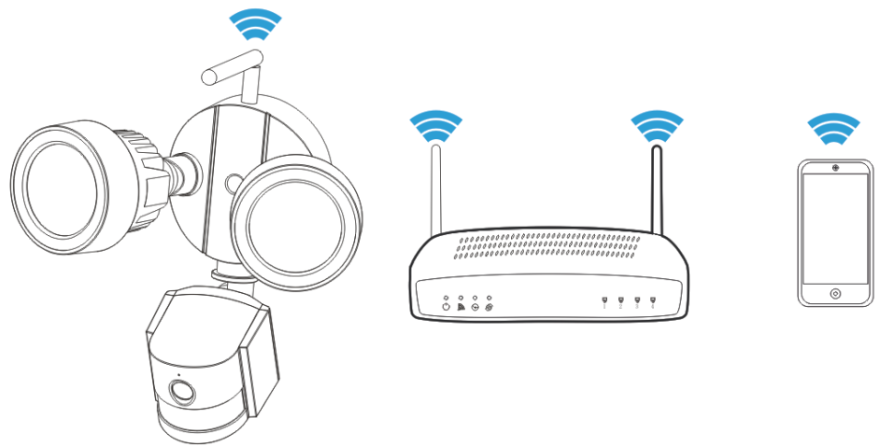

**Features**

•3 in 1: HD IP camera + flood lighting + PIR sensor

• Turn on/off lighting manually or automatically

•SD card recording

•Alarm notification push automatically

• Wireless connection

**Quick Start Guide**

**Step1**: Download mobile App

**Step2**: Connect the camera to router

**Step3**: Add camera in the App

**Step4**: Install the camera

**Step5**: Enjoy remote operation

**Important Safety Instructions**

• Make sure product is fixed correctly and stable if fastened in place.

• Do not operate if wires and terminals are exposed.

• Apply for garden/square/wall/garage etc..

**Default Password Information**

• To ensure your privacy, this device supports password protection.

• The default, all-access username is **admin**, the default password isempty.

• To ensure your ongoing privacy, we strongly recommend setting a new password as soon as possible.

|  |  |
| --- | --- |
| **2** | **Package contents** |

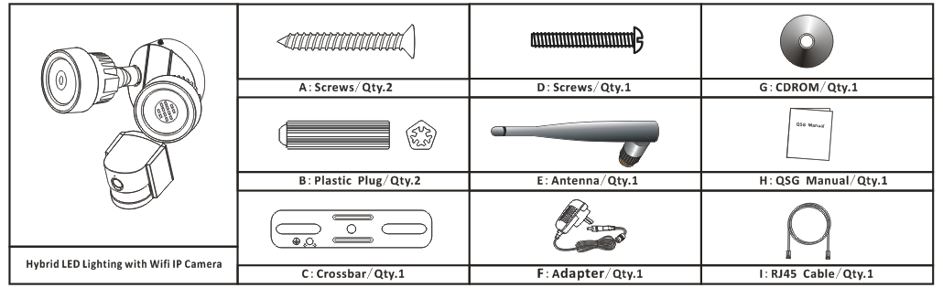

|  |  |
| --- | --- |
| **3** | **Appearance** |

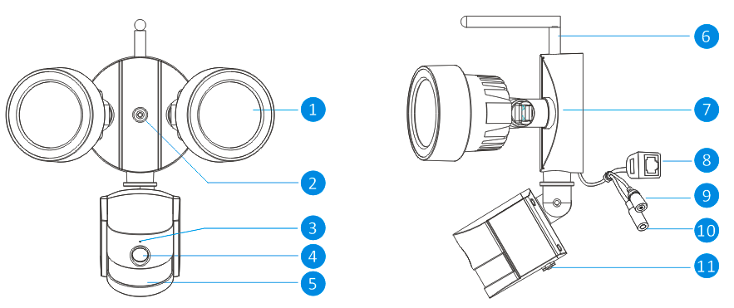

Front view Side view

|  |  |  |
| --- | --- | --- |
| **No.** | **Name** | **Description** |
| 1 | White light source | The camera will use these in low-light conditions to generate a black and white image, even in total darkness. |
| 2 | Fixed hole | The camera can be fixed on a wall with screw through this hole. |
| 3 | Microphone | Allows the camera to pick up nearby sounds, and stream them with the video. |
| 4 | Lens | The business end of the camera. For a reliable and clear image, ensure that the lens stays clean and unobstructed. To clean, use a dedicated lens cleaning solution and cloth, available from all good photography stores. |
| 5 | PIR (Passive infrared sensor) | This is an electronic sensor that measures infrared light radiating from objects in its field of view. |
| 6 | Antenna | Used to transmit the wireless signal to the router. For the best results, the antenna should be as unobstructed as possible - ideally having a clear line of sight to the receiver. |
| 7 | Mounting bracket | The supplied mounting bracket can be screwed onto any flat surface. |
| 8 | RJ45 Ethernet connector | For a wired connection, connect this to a spare port on your home router. so you can use the **ismsee** App on your mobile device. |
| 9 | Reset button | Long press and hold it over 15senconds when the power is disconnected and reconnected, all settings will revert to the factory defaults. |
| 10 | Power socket | Connect the power adapter here.(DC12V/2A) |
| 11 | TF card slot | Insert a TF card for allowing you to capture a series of snapshots and video files. |

|  |  |
| --- | --- |
| **4** | **Installing the mobile App** |

The hybrid LED lighting with HD Wi-Fi Security Camera works with iPhone, iPad and Android devices.

Install the mobile App and use your mobile for remote viewing/control your camera.

The mobile App is free to download for you, and is available from the respective Apple App Store and Google Play Store.

**4B To install App on iPhone/iPad①**  Open the App Store.

**②** Search for “**iSmsee**”.

**③** Tap **INSTALL APP** to download.

**4A To install App on Android**

1. **①** Open Google Play Store.
2. **②**  Search for “**iSmsee**”.
3. **③** Touch **INSTALL**.
4. **④** Review the App’s permissions,
5. then touch **ACCEPT** to download.

After installing **iSmsee** App on your mobile device, just locate the **iSmsee** App and tap the icon to run. The App will load and take you directly to the **Device list** screen.

|  |  |
| --- | --- |
| **5** | **Connecting the camera to your network** |

**5A How to add camera in the App**

The camera works with your home Internet connection and wireless router. There are 3 ways you can follow to set up the camera with your Wi-Fi network.

**Method1: One Key to Add Camera**

This method is provided to add camera without connecting a network cable, it named as “One key to add”. It’s the prior adding method, but if it failed, please try another two methods. (Explained in the part6)

**■Preparation**

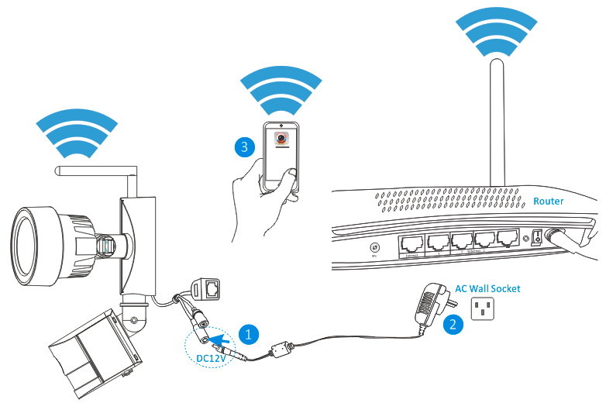

**①** Connect the output of the supplied 12V power adapter into the power socket on the camera.

**②** Plug the power adapter into the wall socket.

**③** Connect your mobile phone to your home wireless router.

**■Add camera**

Wait for about 90 seconds when the camera started up then run the “**iSmsee”** App and operate according to the below steps:

**①** Tap “Add device” to enter the “adding device” screen.

**②** Tap “One key to add device” to enter the next screen.

**③** Enter the WI-FI router password.

**④** Tap “Start Configuration”, then take the mobile phone speaker aimed at the MIC hole on the camera.

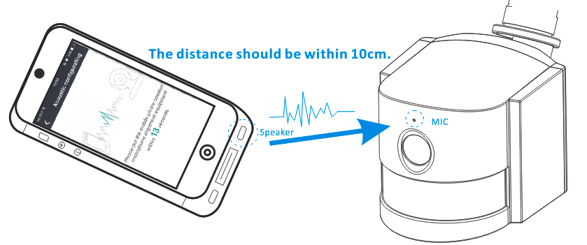

**⑤** After the camera configuration success, then the APP can find the camera DID and show it out.

Tap the DID in the list and then enter the adding camera screen.

**⑥** Enter the camera password.

**Notice: The camera factory Settings password is empty, so when the first using of the camera, no need to enter the password here and can tap the “Done” directly.** **(The same below)**

**⑦** Tap“ Done” to save.

**⑧** Now the camera is added in the “Devices” list successfully.

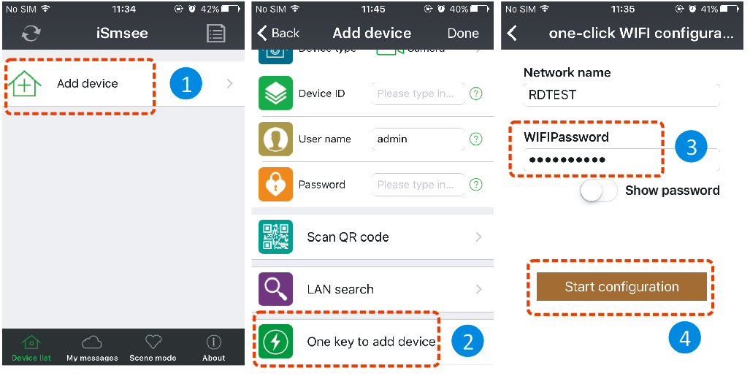

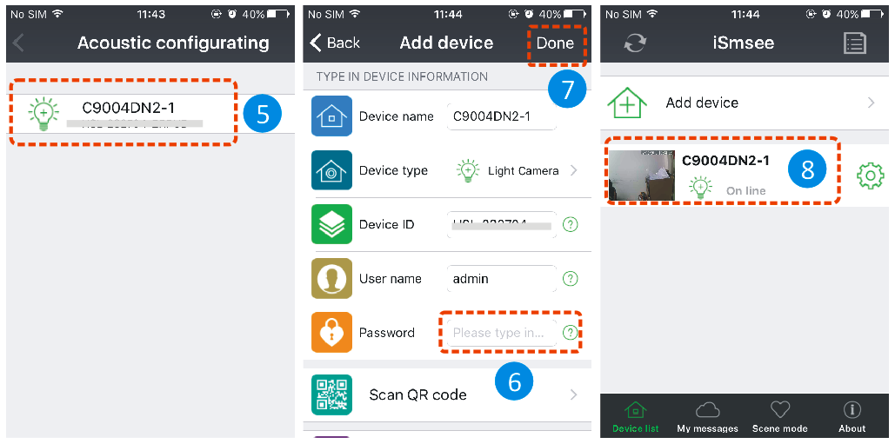

**Method2: Scan the camera’s QR code or input the DID directly**

**■Preparation**

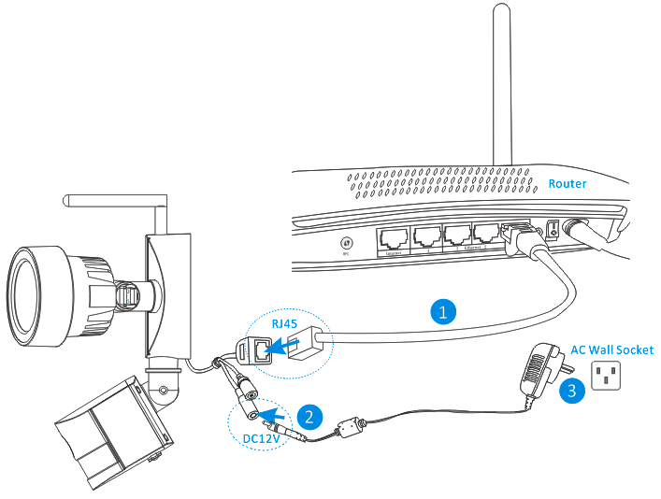

**①** Connect the RJ45 Ethernet connection on the camera, to a spare port on your router using the included Ethernet cable (or a longer one if required).

**②** Connect the output of the supplied 12V power adapter into the power socket on the camera.

**③** Plug the power adapter into the wall socket.

Now the camera is initializing and it will last about 90 seconds then enter normal status.

**■Add camera**

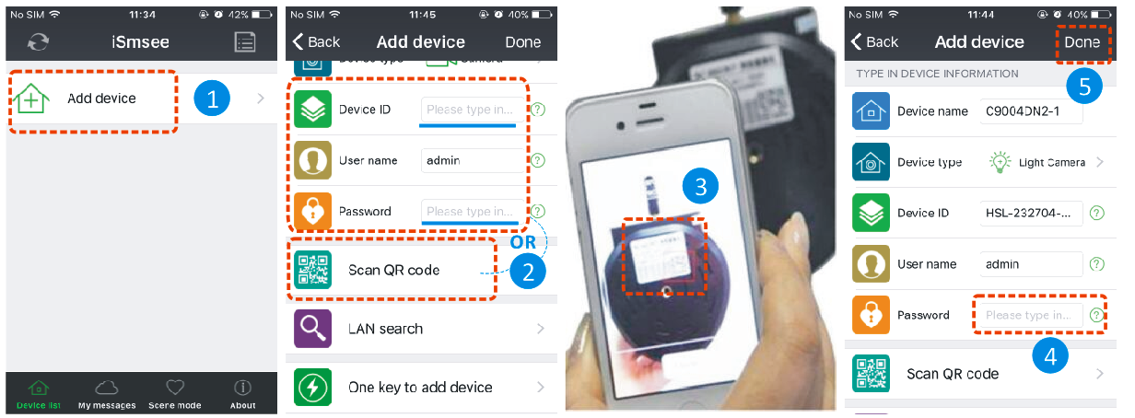

**①** Run the APP, and Touch the “Add device” to enter the adding device screen.

**②** Tap “Scan QR code” to enter the QR scanning status or enter the camera DID number and password,

then skip to ⑤ .

**Notice: If there is prompt that whether authorize the APP for mobile phone cameras, please select YES.**

**③** Make mobile phone’s lens aim at the QR code on the camera and scan it.

**④** Enter the camera password.

**⑤** Tap “Done” to save.

**Method3: Search camera in the LAN**

**■Wired network connection is same as method2.**

**■Add camera**

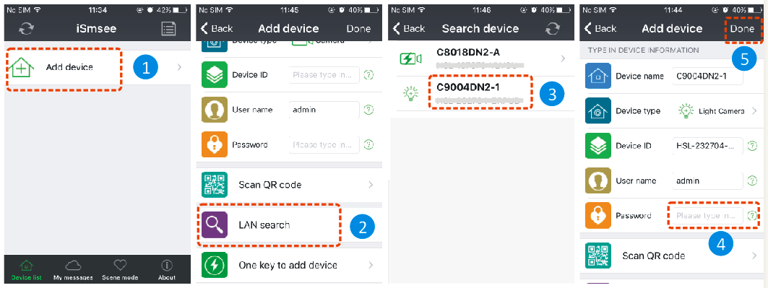

**①** Run the APP, and Touch the “Add device” to enter the adding device screen.

**②** Tap “LAN search” to enter the “Search device” screen for searching the camera in the LAN

**Notice: Both mobile and camera should be connected to the same Wi-Fi router.**

**③** If search out the DID, can directly Touch the camera then return to “Add device” screen.

**④** Enter the camera password .

**⑤** Tap “Done” to save.

**5B Wireless Network Connection**

If you want to connect the camera to router with WI-FI, please enter the camera **setting—WI-FI setting** to set up, steps shown in the figure below:

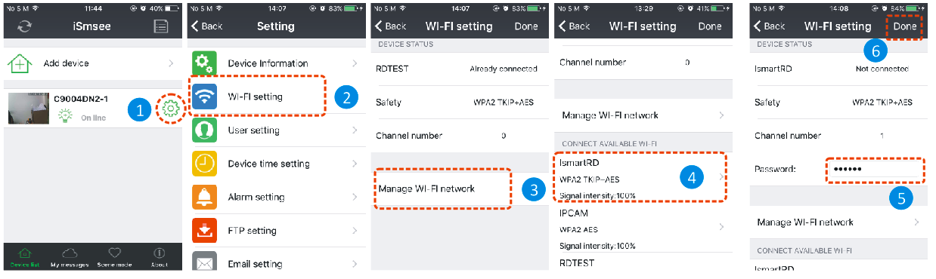

**①** Run the APP, Touch the gear shape icon to enter the camera setting screen.

**②** Tap “WI-FI setting” to enter the WI-FI setting screen.

**③** Tap “Wi-Fi Manager” to search the nearby WI-FI signals.

**④** Select one WI-FI SSID which wanted to connect, and tap it.

**⑤** Enter the WI-FI router password.

**⑥** Tap “Done” to save. Now the camera will restart and the RJ45 network cable can be pulled out.

**Notice: If need help, please Touch the “About”—“Help” in the APP, there is detailed description for each icon. The Android and IOS screen styles are basically the same, both of them can be operated according to this instructions.**

|  |  |
| --- | --- |
| **6** | **Insert a Micro-SD card for recording** |

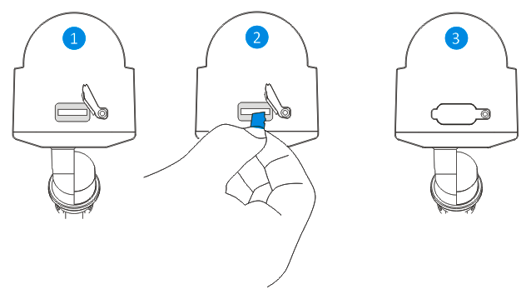

**①** Open the card slot cover.

**②** Insert a micro-SD card to the slot, please attention direction.

**③** Close the card slot cover.

|  |  |
| --- | --- |
| **7** | **Install the Wi-Fi antenna** |

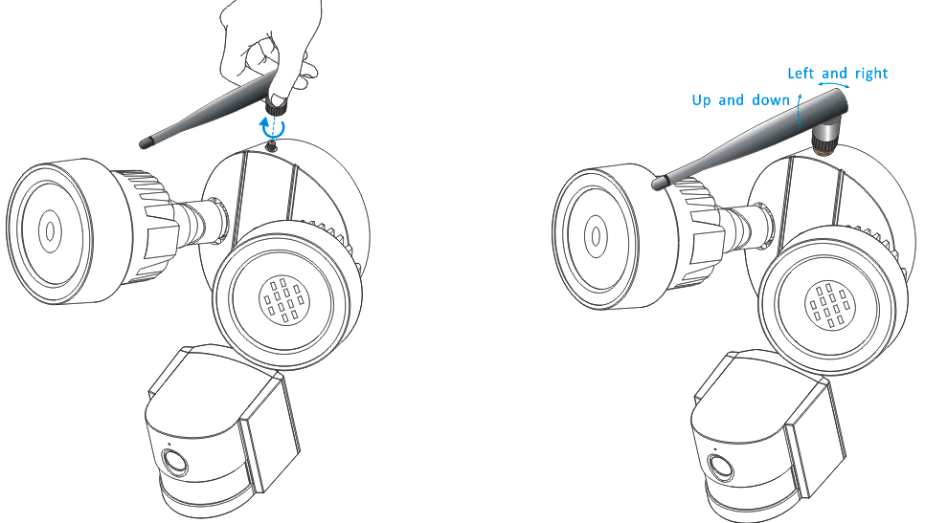

Use a clockwise motion to connect the antenna.

Make sure the antenna is connected firmly but not excessively.

It is recommended to leave the antenna in a vertical position for best reception.

|  |  |
| --- | --- |
| **8** | **Camera installation guide** |

**Confused on which location to install your camera?** The camera can be installed in a number of different locations. Camera location can depend on the following -

**8A Camera Location Tips**

You may need to install multiple cameras if you want to focus on specific areas that you would like to monitor, for example, one for the garden, the other on the front gate entrance.

•Distance from the camera to the recording device.

•Environmental conditions such as rain or snow.

•Lighting conditions during the day and night.

• The area that you would like to monitor.

When you position cameras correctly, you can eliminate the need for additional cameras to cover your target area and maximise the efficiency of your security system. On the flip side, if you position cameras incorrectly, it can lead to blind spots or to have objects that are not visible or too far for the cameras to view in detail. Keep these points in mind to get the most out of your security system.

**Mount cameras at an elevated position** - Mounting your cameras at an elevated position, can keep your cameras out of range of vandals or would be burglars. It also allows your camera to have a high vantage point increasing its viewing area.

**Cover your target area** - When placing cameras, make sure you provide ample coverage, but not in excess. For example, if you are trying to cover a front gate, don’t zoom in to only have the gate in frame. Position the camera to cover part of your front gate so you capture as much area as possible without sacrificing video quality.

**8B Camera Field of View**

The Field of view produced by a camera is the area that the camera can see. It is an important factor to consider as it determines not just what the camera can see, but also the level of detail that is visible at a given distance. Cameras with a smaller lens, also known as a wide-angle lens, produce a greater Field of View than cameras with a larger lens. This means that the camera can see a large area but the objects will Appear smaller within the scene area. This is useful if you want to monitor an entire room or a yard. Cameras with a larger lens also known as narrow-angle have a smaller Field of View. They can see a limited area, but objects will Appear larger within the scene area. This is useful if you want to monitor a specific target such as a doorway or entrance. **The included camera’s lens is 3.6mm by default.**

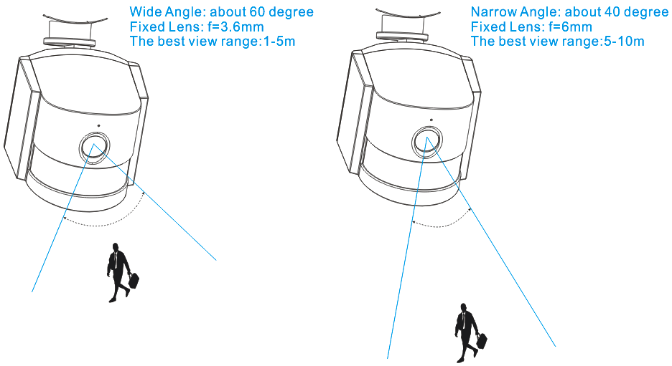

**8C Lighting & Environment Tips**

**Lighting**

• For best results do not point the camera towards a light source.

• Pointing the camera towards a glass window intending to see outside may result in a poor image because of glare and lighting conditions inside and outside.

• Don’t place the camera in a shaded area that is looking into a well lit area as this will result in a poor display. The light to the sensor located at the front of the camera needs to be the same as the light at the focal target for best results.

• As the camera uses infrared LEDs to see at night, it’s recommended to clean the lens from time to time if the picture degrades.

**Environment**

• Make sure the power connections are not directly exposed to water or moisture and shielded from other outdoor elements.

• Weatherproof only means that the camera can be exposed to weather such as rain and snow.

Weatherproof cameras cannot be submerged under water.

• Do not expose the camera where rain and snow will hit the lens directly.

• Cameras geared for cold weather may work in extreme conditions as low as -25° as the camera produces heat when plugged in.

**8D Tools Required (not included)**

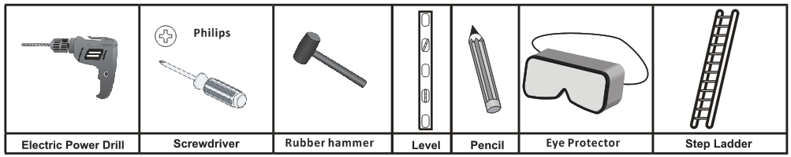

**8E Installation Steps**

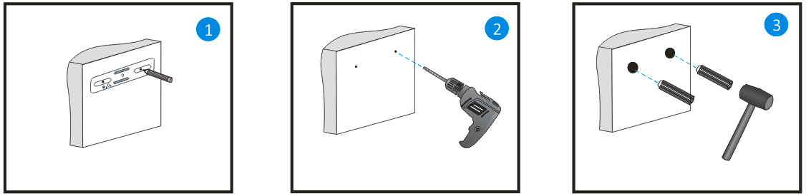

Use an electric power drill to drill the holes in the chosen mounting surface according to the mark.

Choose the place you would like to set this fixture.

Use a pencil to mark the 2 screw holes on the chosen surface. A level may be required.

Use a rubber hammer to hit the included plastic plugs into the holes. Ensure the plastic plugs be fixed into the wall without loose.

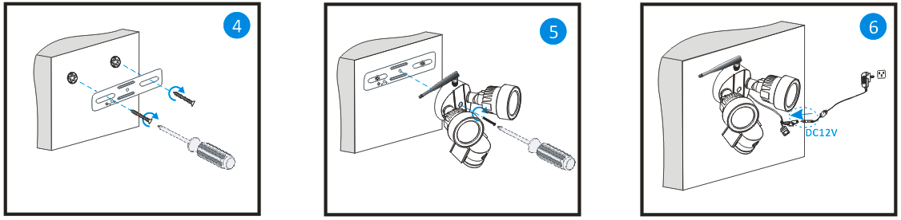

Connect the output of the supplied 12V power adapter into the power socket on the camera.

Then plug the power adapter into the wall socket.

Put the included screw (D) through the center hole of the camera bracket and crossbar. Tighten the screw properly to secure the camera onto the wall.

Use a screw driver to screw the crossbar into the chosen surface with the included screws (A).

**8F LED and Camera Angle/Direction Adjustment**

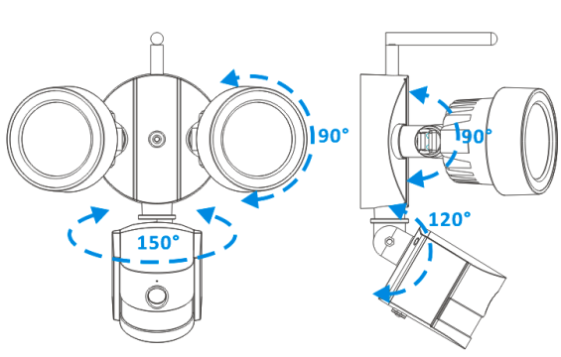

|  |  |
| --- | --- |
| **9** | **Main function introduction** |

**9A LED working mode**

**■Turn on /off LED manually**

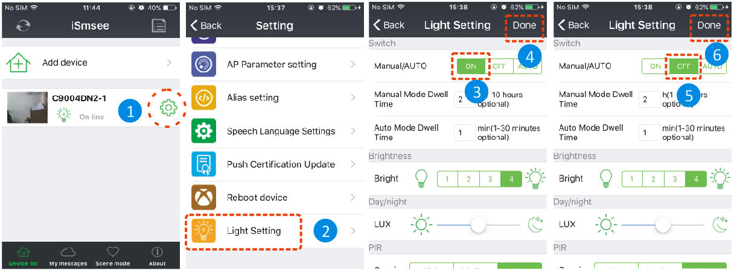

**①**Run the App, on the “**Device List**” screen ,touch the gear shape icon to enter the selected camera setting screen.

**②** Tap “Light Setting” to enter the light setting screen.

**③** Select “Switch\Manual/Auto” to **ON**.

**④**Tap “Done” to save and the LED will be on.

**⑤**Select “Switch\Manual/Auto” to **OFF**.

**⑥**Tap “Done” to save and the LED will be off.

**■LED ON Delay time setting at manual mode**

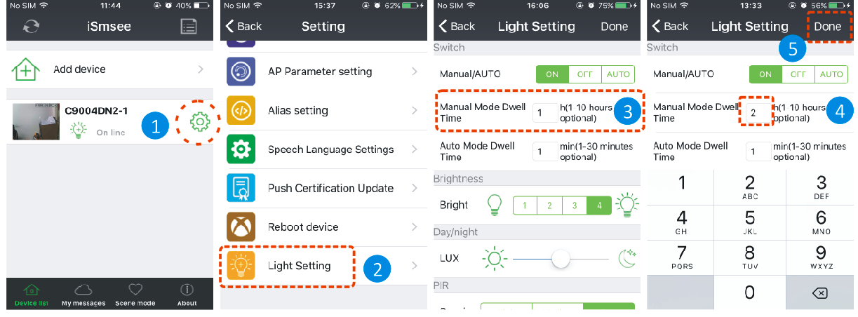

**①**Run the App, on the “**Device List**” screen, tap the gear shape icon to enter the camera setting screen.

**②** Tap “Light Setting” to enter the light setting screen.

**③** Tap “Manual Mode Dwell Time” input box.

**④** Enter required delay time from 1 to 10 hours.

**⑤**Tap “Done” to save.

**■Auto mode**

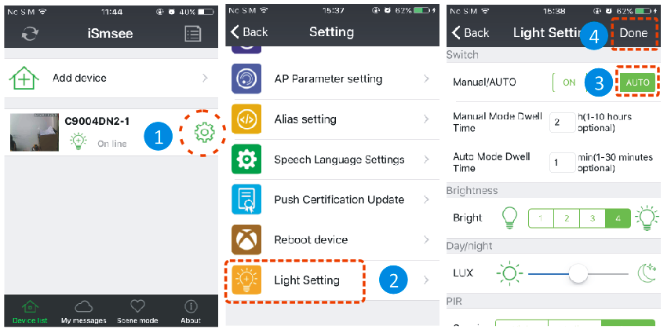

**①**Run the App, on the “**Device List**” screen, tap the gear shape icon to enter the camera setting screen.

**②** Tap “Light Setting” to enter the light setting screen.

**③**Select “Switch\Manual/Auto” to **AUTO**.

**④** Tap “Done” to save.

Now the camera is working at auto mode, the LED lighting won’t be turned on during the daytime, but when it gets dark or at night and someone enters the surveillance area, the LED lighting will be turned on and lasting a period time which you preset. Finally the LED lighting backs to off status.

**■LED ON Delay time setting at Auto mode**

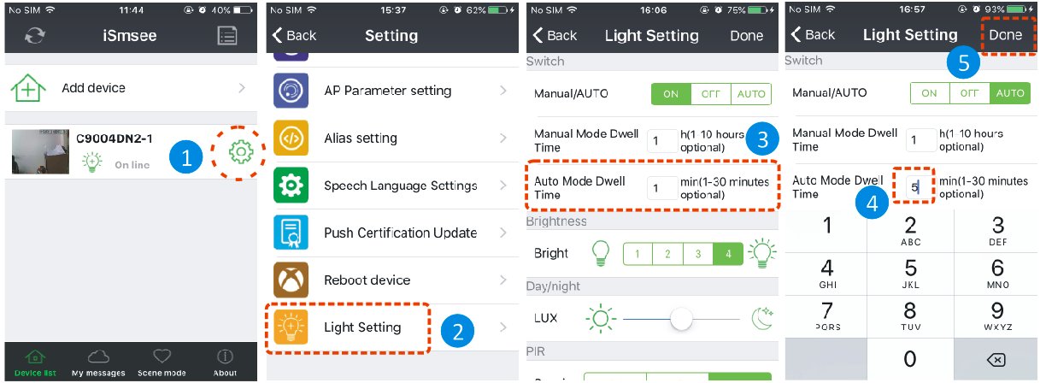

**①** Run the App, on the “**Device List**” screen, tap the gear shape icon to enter the camera setting screen.

**②** Tap “Light Setting” to enter the light setting screen.

**③** Tap “Auto Mode Dwell Time” input box.

**④** Enter required delay time from 1 to 30 minutes.

**⑤** Tap“Done” to save.

**9B Environmental illumination threshold setting for Day/Night mode switch**

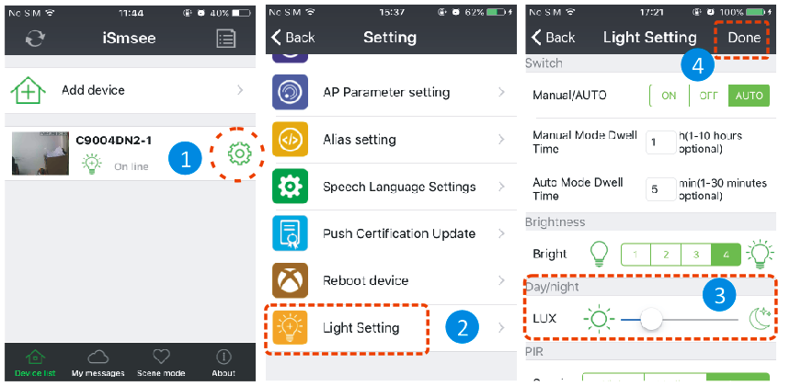

**①** Run the App, on the “**Device List**” screen, tap the gear shape icon to enter the camera setting screen.

**②** Tap “Light Setting” to enter the light setting screen.

**③** Slide the LUX bar between icon and  to set up Day/Night switch threshold. You can adjust it according to your needs.

**④** Tap “Done” to save.

**9C PIR trigger sensitivity setting**

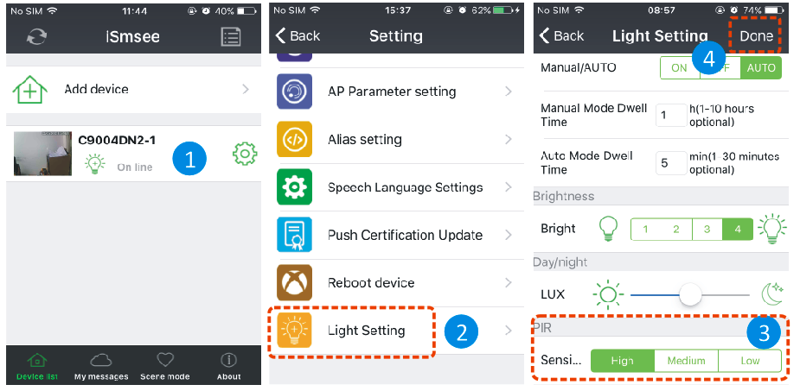

**①** Run the App, on the “**Device List**” screen, tap the gear shape icon to enter the camera setting screen.

**②** Tap “Light Setting” to enter the light setting screen.

**③** Tap one of the High/Medium/Low button to setup PIR sensor trigger sensitivity. This will adjust how sensitive the camera will be when detecting events. You can adjust it according to your needs.

**④** Tap “Done” to save.

**9D Notification push setting for PIR trigger**

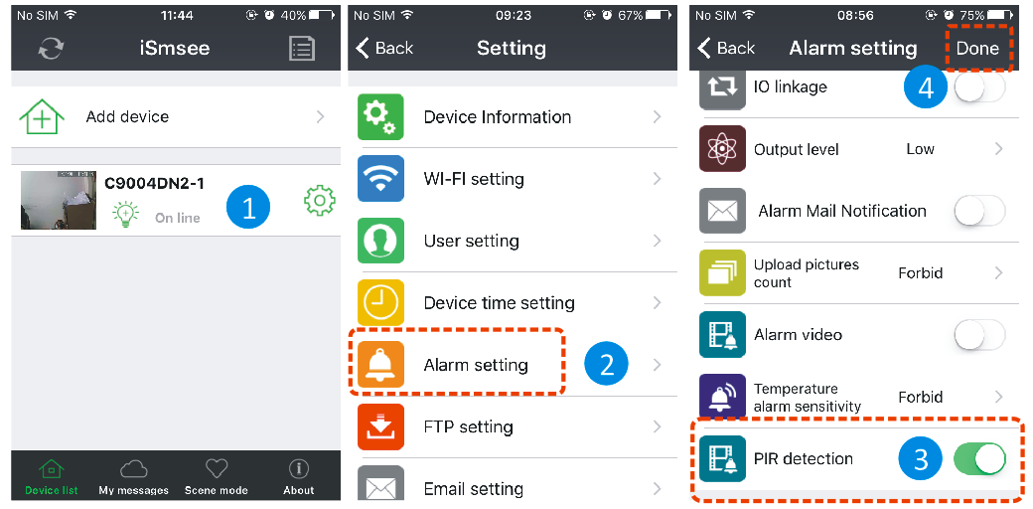

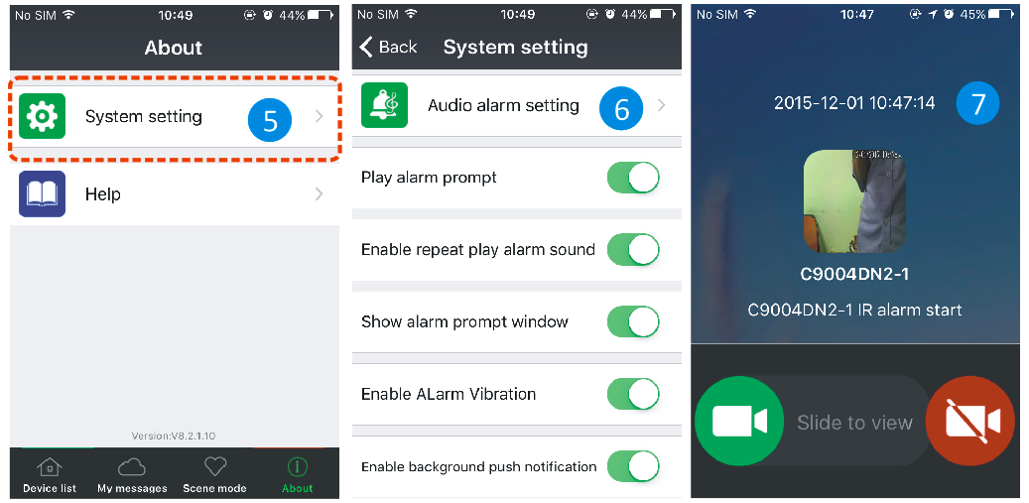

**①** Run the App, on the “**Device List**” screen, tap the gear shape icon to enter the camera setting screen.

**②** Tap “Alarm Setting” to enter the alarm setting screen.

**③** Enable or disable PIR detection, means enable notification push,  means disable notification push.

**④** Tap “Done” to save.

**⑤** Tap “About\System setting” to enter system setting screen.

**⑥** Enable all items on this screen.

**⑦** When enable the PIR detection and someone enter the surveillance area, your mobile will pop up a message, then you can slide it to view.

**9E Notification push setting for Motion Detection trigger**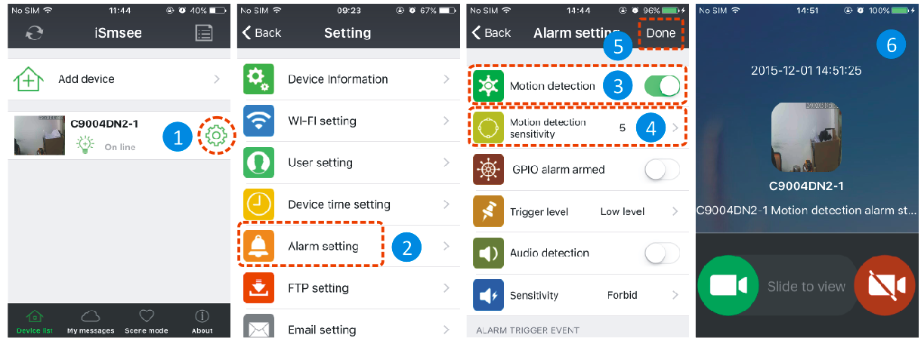

**①** Run the App, on the “**Device List**” screen , tap the gear shape icon to enter the camera setting screen.

**②** Tap “Alarm Setting” to enter the alarm setting screen.

**③** Enable or disable motion detection.

**④** This will adjust how sensitive the camera will be when detecting events. The default value of 5 will work in most environments, but you can adjust it according to your needs.

**⑤** Tap “Done” to save.

**⑥**When enable the motion detection and someone moved at the surveillance area, your mobile will pop up a message, then you can slide it to view.

**9F Recording to a Memory Card**

You can insert a micro SD card into card slot (Refer part6 to see how to insert card) for continuous recording.

The camera supports Micro-SD memory card of up to 64GB. 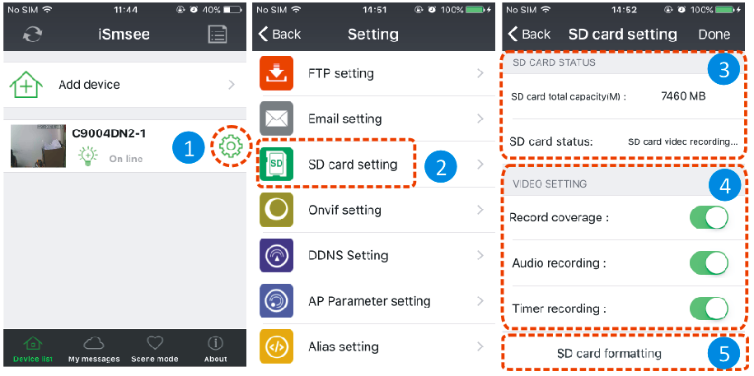

**①** Run the App, on the “**Device List**” screen,tap the gear shape icon to enter the camera setting screen.

**②** Tap “SD card Setting” to enter the SD card setting screen.

**③** Here display the SD card total capacity, you can check the SD card inserted or not.

**④** Enable all items

**⑤** Format SD card when you need. Please note it will delete all the recordings.

**9G My messages**

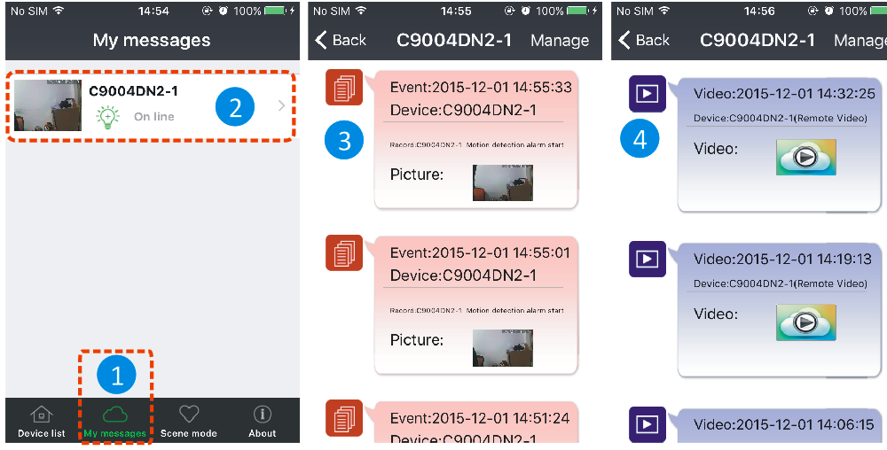

**①** Run the App, on the “**Device List**” screen, tap “**My messages**” to enter my messages screen.

**②** Tap a selected camera to enter next screen.

**③** Tap to view a picture captured when motion or PIR detection event occurred up.

**④** Tap to play back video.

|  |  |
| --- | --- |
| **10** | **Specifications** |

|  |  |  |
| --- | --- | --- |
| 1 | Image sensor | 1/4 " 1Megapixel color CMOS |
| 2 | Max Image Resolution | 1280*720 |
| 3 | Lens | f=3.6mm@ F1.2 ,Horizontal field of view:60.4° |
| 4 | Day/Night | Built-in IR-CUT |
| 5 | Video Compression | H.264 /MJPEG dual video stream |
| 6 | Audio Compression | ADPCM |
| 7 | Light source | 5W high-power LED * 2pcs |
| 8 | Luminous flux | 650 lumen in average |
| 9 | PIR detection range | 60-70° horizontal, 6-8 meters |
| 10 | LED distance | 10meters |
| 11 | LED on/off control | Manual or Auto two modes |
| 12 | Intelligent Alarm | Motion detection /Sound detection/PIR detection |
| 13 | WiFi protocol | 802.11/b/g/n |
| 14 | Operating Condition | -10℃~60℃,Humidity ≤90% (non-condensing) |
| 15 | Power Supply | DC12V 2A |
| 16 | Power Consumption | ≤15W MAX |
| 17 | IP grade | IP65 |
| **11** | **Troubleshooting** | | | | |

**Q1: I’ve forgotten the username and password of the camera.**

A1: The default username is **admin** and the password is **none**. If you have changed the username and password to something different, you will need to reset the camera back to its default factory settings. To reset the camera, unplug the power adapter from the power socket then press and hold the Reset button while you reconnect the power adapter to the power socket. Release the **Reset** button after a few seconds(more than 15 seconds).

**Q2: I’ve installed the mobile App but I can’t display my camera.**

A2: Assuming your camera is plugged into power, your camera could be experiencing network connectivity issues. Do the following:

1. • Ensure your mobile device is connected to the same Wi-Fi network as your camera.
2. • Check the strength of your Wi-Fi network. Certain wireless products - specifically those that operate in the 2.4GHz range such as Bluetooth systems, baby monitors or cordless telephones, may cause interference with the camera. If possible, place the camera at least 5 meters away from these types of devices to improve reception between the router and the camera.
3. • If you are viewing your camera away from home, there could be an issue with your mobile device’s internet data connection. Check if there is 3G or 4G network connection on your mobile device. (If you’re on the EDGE mobile network, it’ll be too slow to stream video from the camera).
4. • If the problem persists, restart your camera by disconnecting and reconnecting the camera’s power adapter and then open mobile App again to check if this fixes the problem.
5. • If your camera installed far from router and the distance beyond Wi-Fi transmission range, it is strongly recommend add one RJ45 network cable (100meters Max.) to connect camera and router.

**Q3: Images are slow to update or have a poor frame rate.**

A3: The quality of the image and frame rate can be affected several factors -

1. • Network bandwidth: Your network may be slow to handle the amount of data passing through it. Other devices or programs might be consuming the bandwidth that is available. Try removing the other devices to see if the performance improves. Lowering the resolution and bitrate may also improve things.
2. • Computer performance: Your computer may not be powerful enough to handle the live video streams coming in. If you have multiple cameras connected, try viewing them one at a time to see if the performance improves. You can also try viewing the live stream at a lower resolution and bitrate.
3. • Mobile performance: Live stream viewing is dependent on the hardware specifications of your mobile device. Not all mobile devices are made equally. Just like a computer, the speed of the hardware and the memory available will affect performance. Also, the overall speed of your mobile service provider can also play a part. If you are having issues with playback, try viewing the live stream at a lower resolution and bitrate.